#### 22UIT003 Abishek palani S

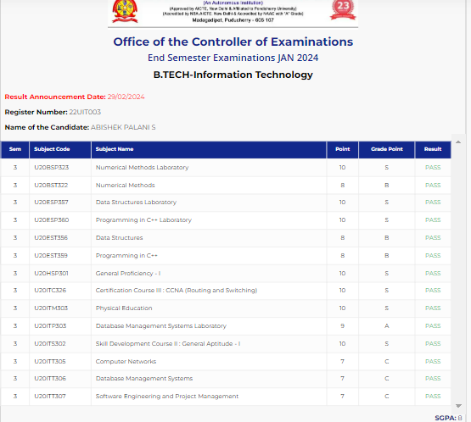

#### 22UIT006 Aiswarya.R

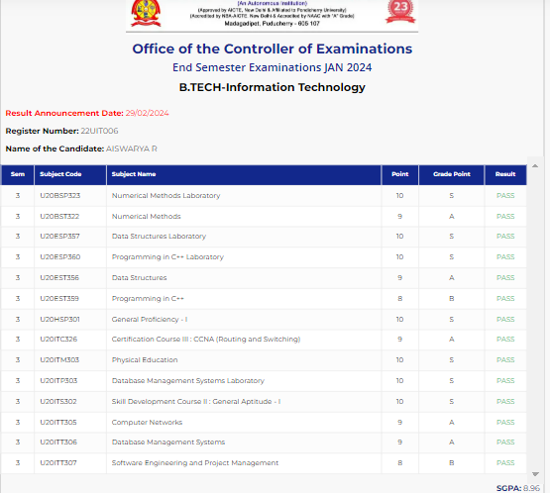

#### 22UIT007 Anburaj.J

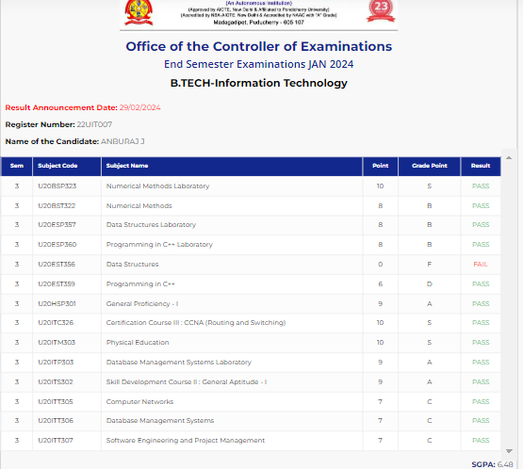

#### 22UIT008 Anubhambika MG

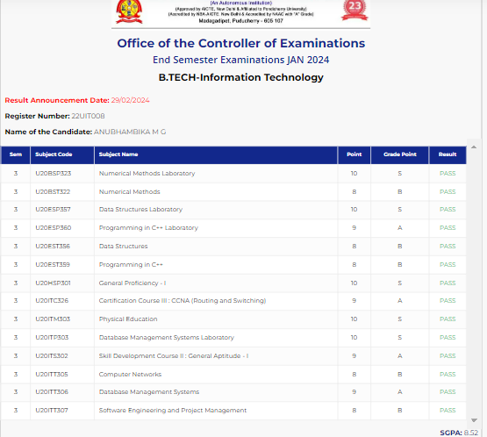

#### 22UIT009 ARAWIND.A.S

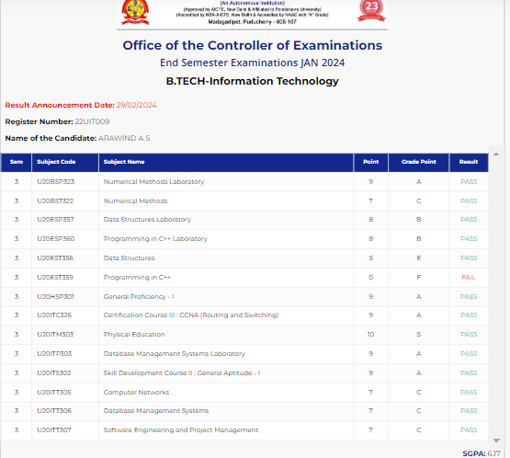

#### 22UIT013 Arun kumar. M

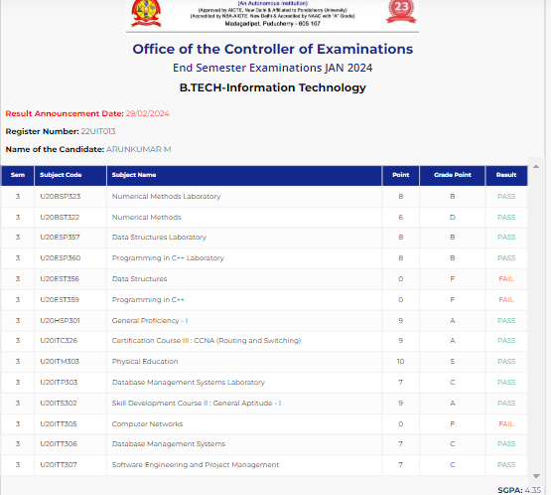

#### 22UIT014 Ashigha.M

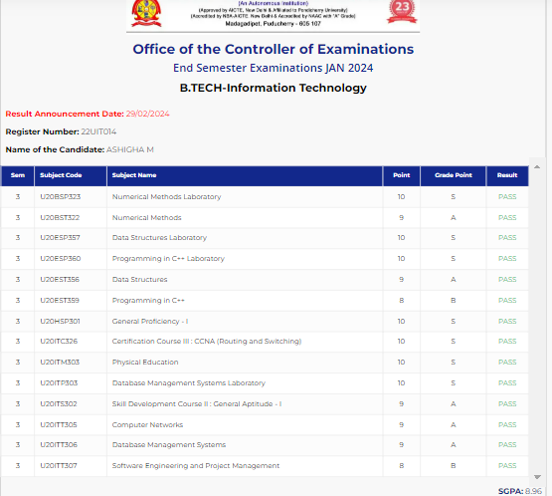

#### 22UIT018 Balamurugan

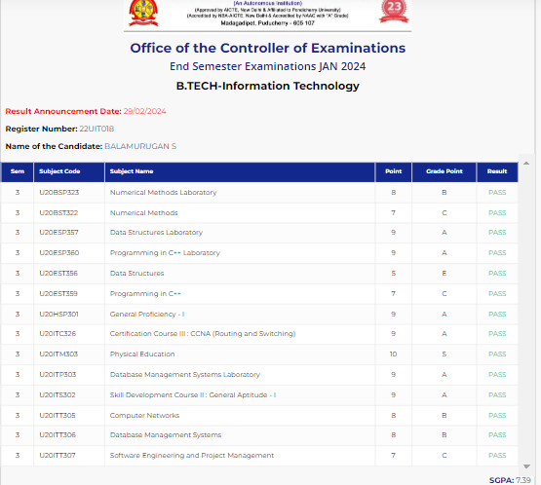

#### 22UIT020 BHUVANESWARI G

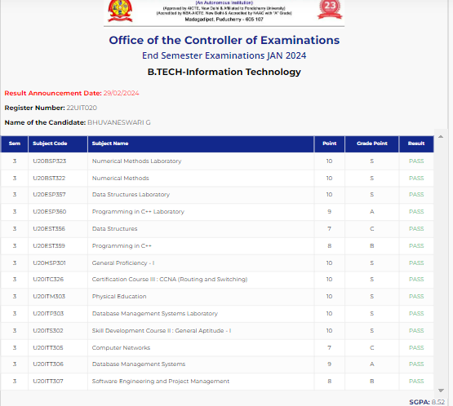

#### 22UIT022 DEEPAKRAJ.R

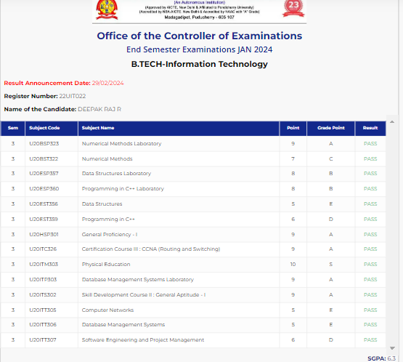

#### 22UIT023 Deshma.P

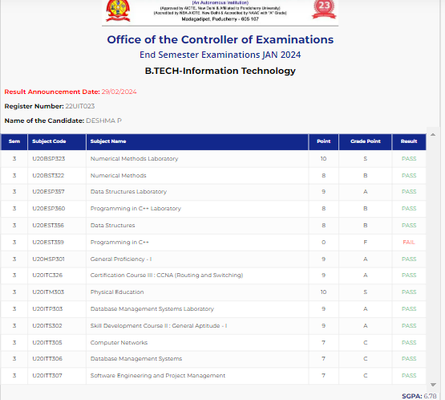

#### 22UIT025 Dhatchayini.R

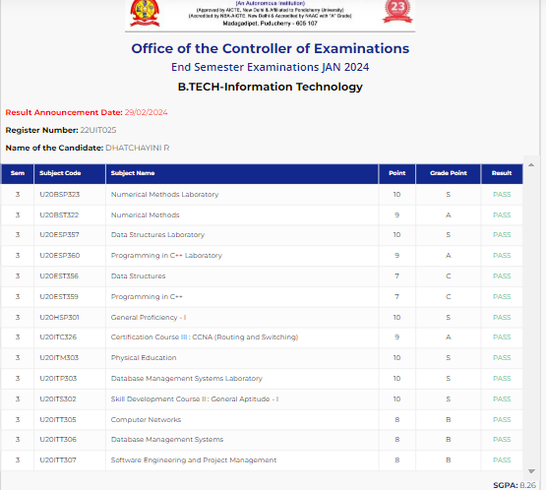

#### 22UIT028 Dhivya. B

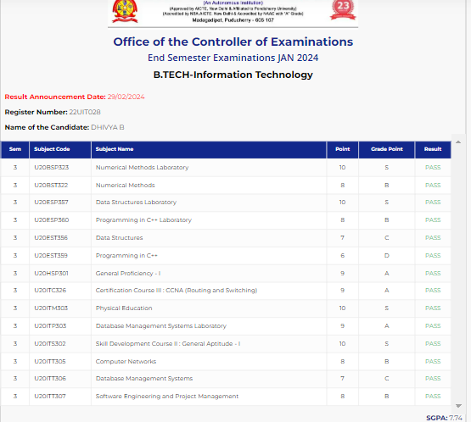

#### 22UIT029 Dinesh kumar.C

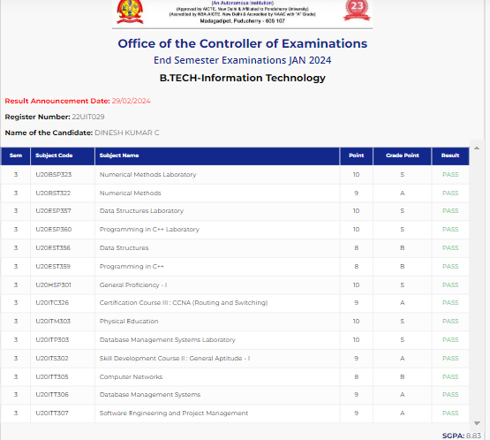

#### 22UIT034 FYZAL.K

#### 

#### 22UIT072 LOGESH.S

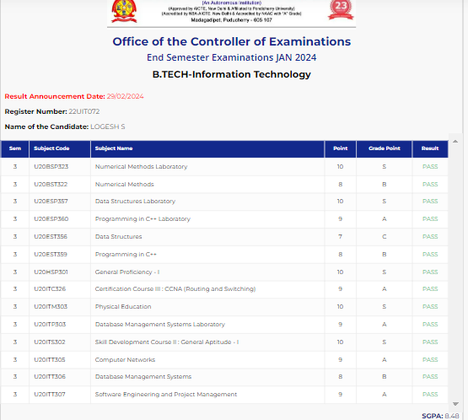

#### 22UIT074 Madhan.c

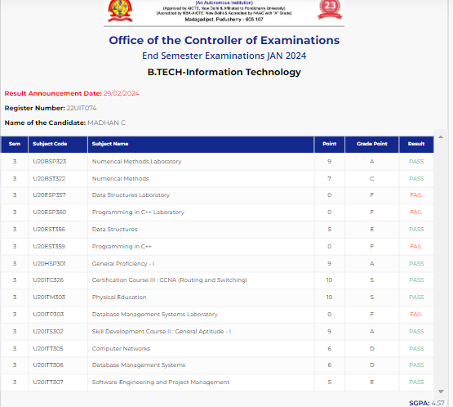

#### 22UIT078 Mithra.I

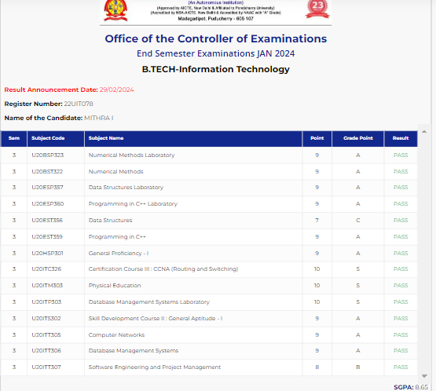

#### 22UIT082 Mona.B

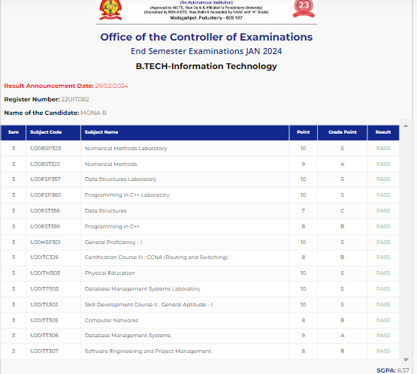

#### 22UIT088 Nandini.V

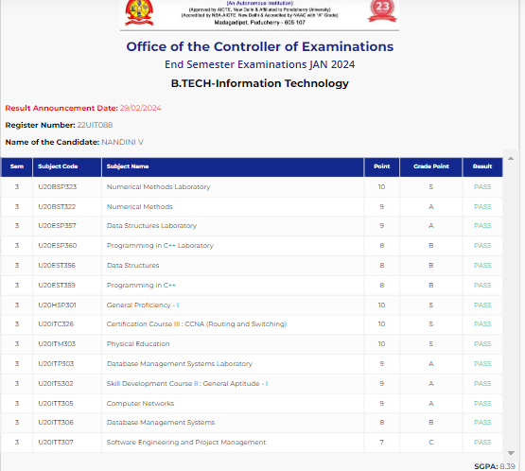

#### 22UIT089 Naraen.M

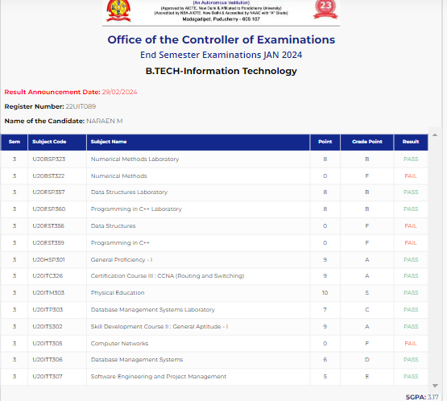

#### 22UIT098 Nithesh Kumar.K

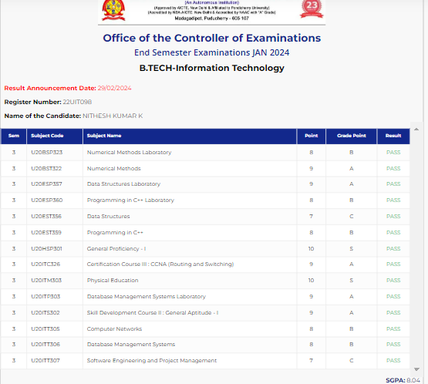

#### 22UIT099 Nithish.G

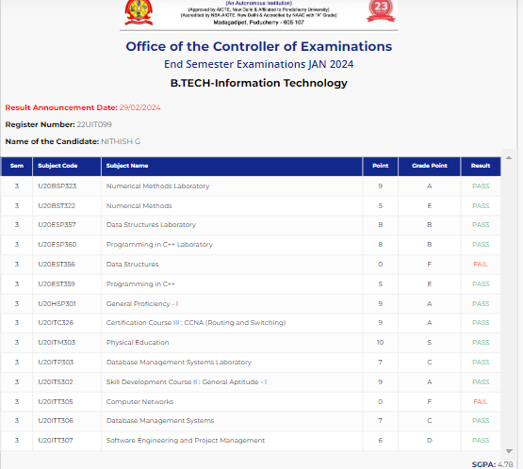

#### 22UIT107 Pradheep.R

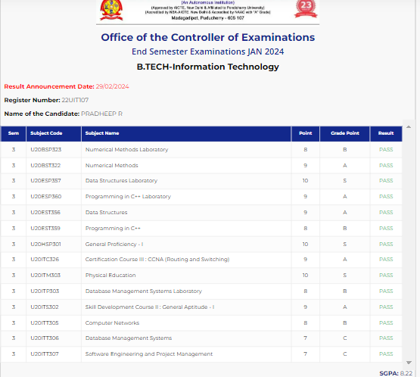

#### 22UIT110 Prasanna.K

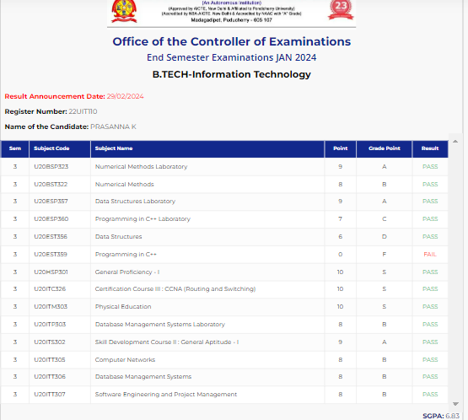

#### 22UIT111 Prasanth.S

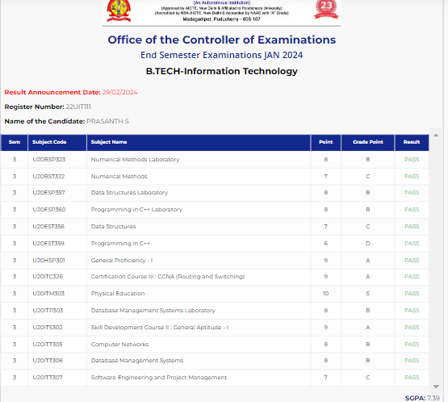

#### 22UIT116 Pydikondala venkata sai vijay prasanth

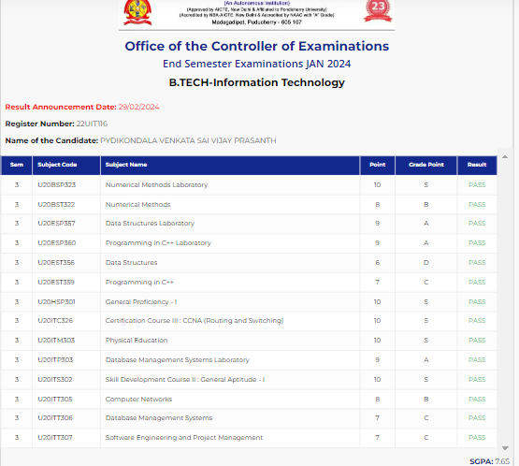

#### 22UIT119 Rajaragavi.R

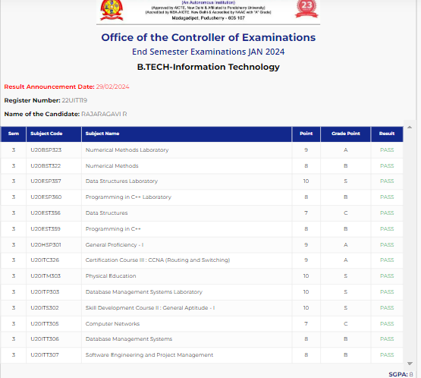

#### 22UIT123 Rukku kanakadas

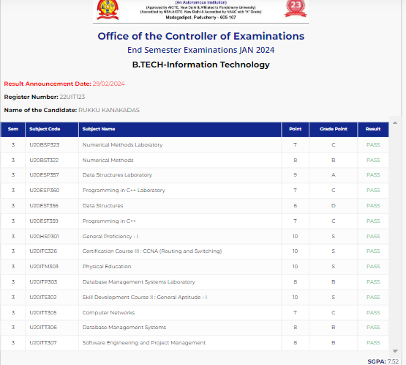

#### 22UIT124 Saathvic.S

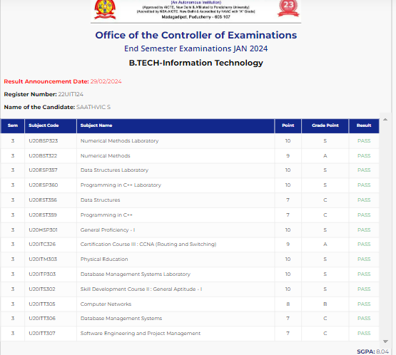

#### 22UIT128 Sai poobbathy.M

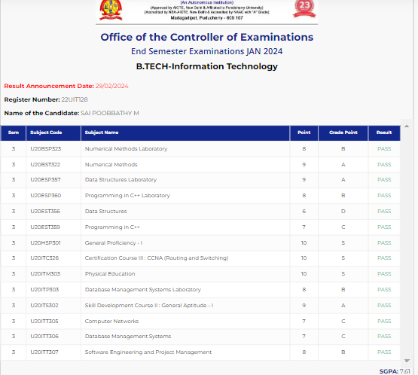

#### 22UIT131 Samson Sambavi.S

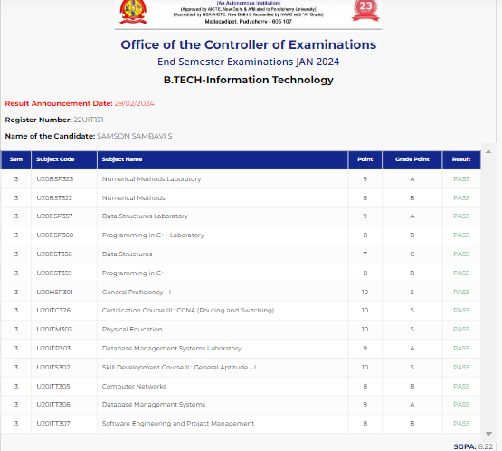

#### 22UIT133 SANJANA.E

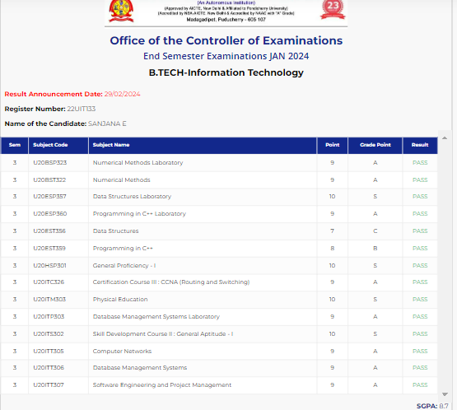

#### 22UIT139 Sengeniammal.N

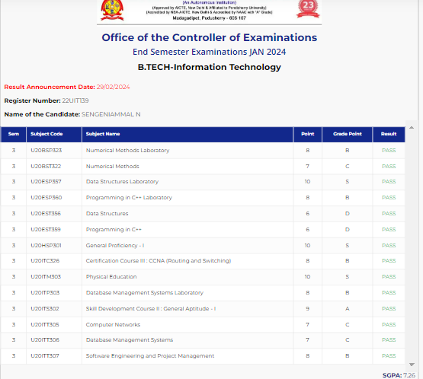

#### 22UIT141 Shamshira.S.B

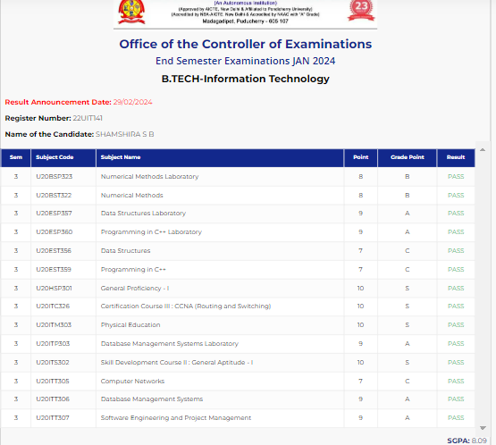

#### 22UIT142 Shankar.R.S

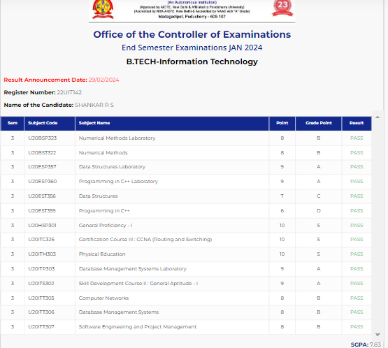

#### 22UIT144 Sharan. S

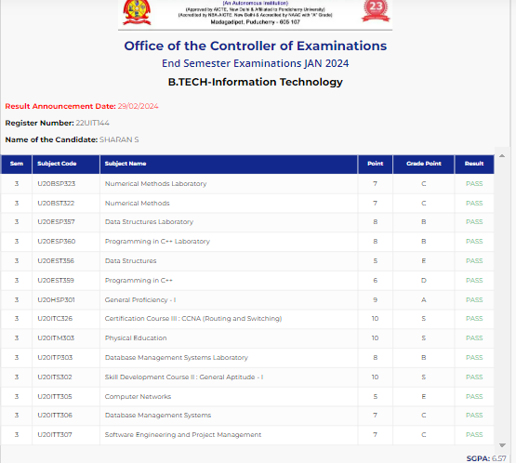

#### 22UIT145 Shiva Parvathan.A.A

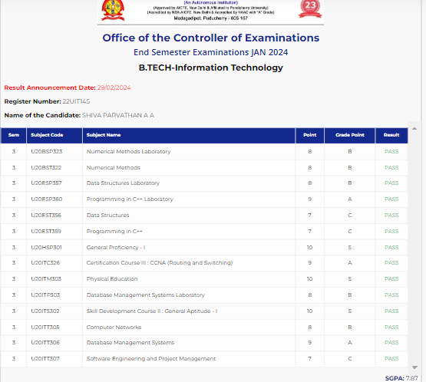

#### 22UIT146 Shivram@Vignesh

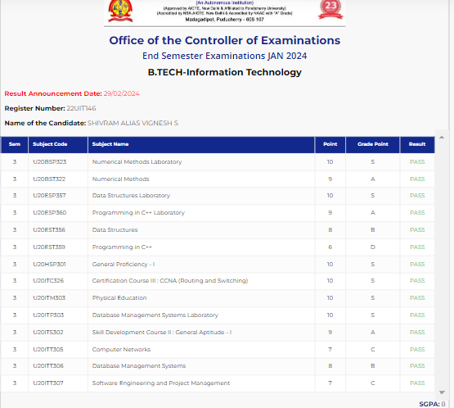

#### 22UIT147 Shobika G

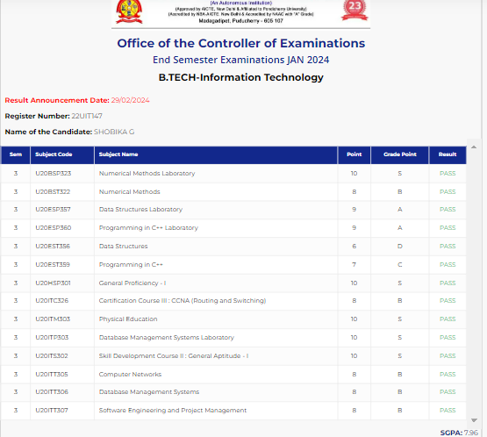

#### 22UIT149 Shriram.S

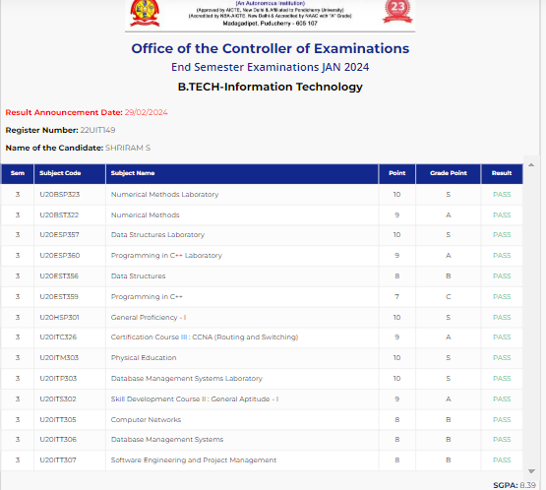

#### 22UIT152 Smitha Keren.M

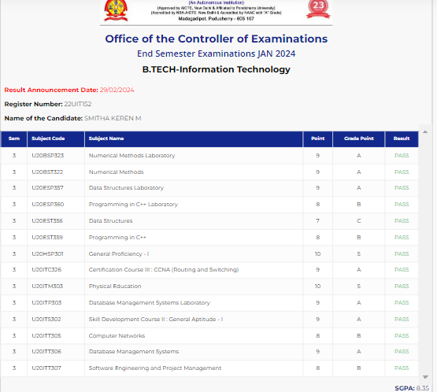

#### 22UIT158 Subhiksha.S

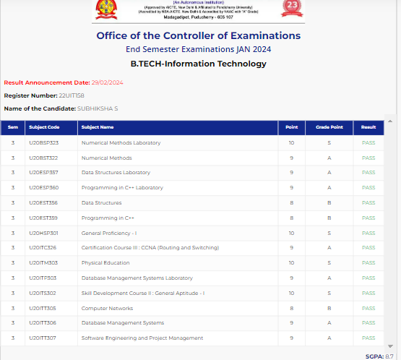

#### 22UIT164 Suriya prasaad.S

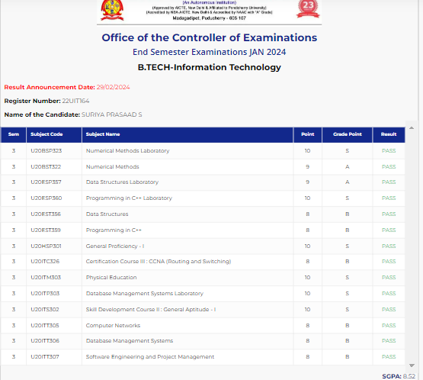

#### 22UIT170 Thamimul Ansari

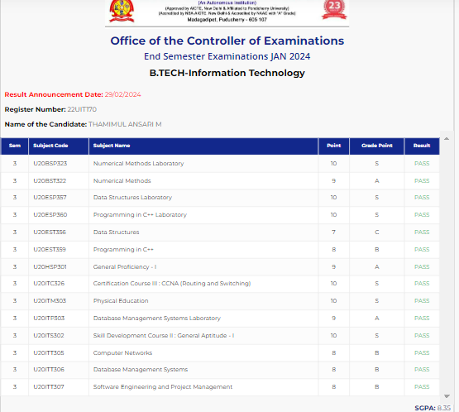

#### 22UIT172 Thilak ragav.M

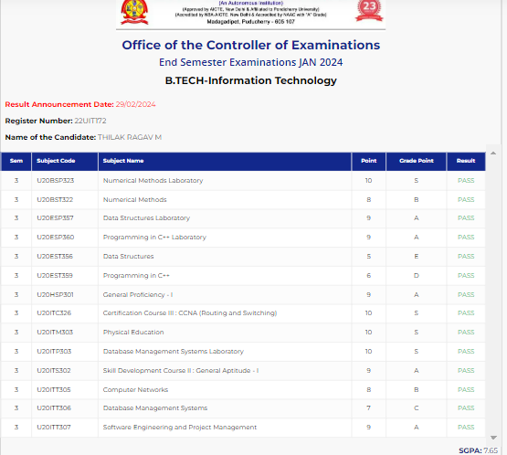

#### 22UIT174 ubendiran.G

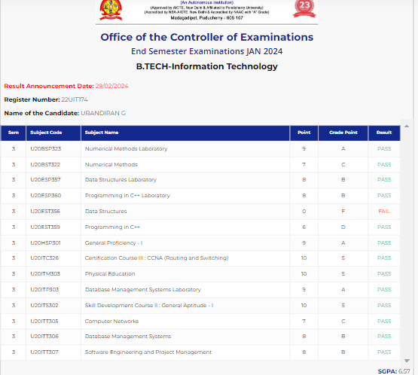

#### 22UIT178 YOGAPRIYA.P

